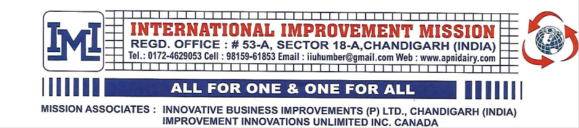
COPY OF MISSION COMMUNICATION ADDRESSED TO HONOURABLE PRIME MINISTER OF INDIA
IIM-IIU-2026 04.05.2026
Sh. Narendra Damodar Das Modi
Honourable Prime Minister of India
Subject: Glass of 100% pure international quality pasteurized milk per day for every Indian citizen
Most Respected Sir
On behalf of our N.R.I. Mission we are trying our best for the last few decades to safeguard the interests of prime beneficiaries of dairy business i.e. milk consumers, needy milk producers and ethical dairy business entrepreneurs by seeking administrative support from our political leaders, administrators and professional experts of premier dairy institutions in India.
Unfortunately dairy experts working with premier dairy institutions of India are intentionally or unintentionally hiding the true facts from their heads of institutions and have no scientifically logical answers for the following pertinent questions related with the subject cited above:
- Why no dairy plant in cooperative or commercial dairy sector is in a position to procure 100% pure raw milk (cow, buffalo or mixed whole milk) strictly conforming to international quality specifications relating to purity of contents, microbiological safety and shelf life (without any dilution with non- potable added water and manipulation of natural S.N.F: FAT ratio )?
- Why no dairy plant in India has any instrument or technology to analyse true net worth of raw mixed milk based on exact % of cow milk, buffalo milk and added water in that milk being received through road milk tankers on dairy dock of all dairy plants?
3. Why no dairy plant in India is marketing pasteurized milk strictly conforming to international quality standards relating to purity of contents, microbiological safety and shelf life of more than two weeks?
4. Why no dairy expert working with premier dairy institutions has answered simple quiz questions relating to milk purchase transactions asked by our mission associates in the questionnaire of all India quiz competitions and claimed complementary prize of Rs five lacs.
5. Why many iconic business houses of India who ventured in to dairy business during last few decades and ultimately walked out of dairy business after suffering heavy losses due to manipulation and dilution in milk purchase transactions?
We all know that highlighting a problem without evolving a scientifically logical solution of the problem would serve no useful purpose. Good news for all of us who love their motherland is that our Mission associate in Canada has designed an instrument called ``MILK-O-METER`` with tri- colour indicator scale to distinguish between buffalo milk, cow milk and mixed milk and also devised a software solution based on ``DIGITAL HYDRO ANALYSIS TECHNIQUE`` to analyse true net worth of raw mixed milk containing (buffalo milk +cow milk + added water) being received through road milk tankers on the dairy dock of our milk plants.
Besides it they have also designed fool proof transparent and accountable “ APNI DAIRY MILK PROCUREMENT SYSTEM” from milk producer up to dairy plant for purchasing 100% pure raw milk strictly conforming to international quality parameters and eradicating abnormally high undetected hidden loss of crores of rupees everyday being suffered by almost all dairy plants in India due manipulation of natural S.N.F. :Fat ratio and dilution of raw mixed milk with about 20% non- potable added water and converting that water as additional cow milk in manipulated milk purchase /billing/payment records.
Dairy experts may please go through our Mission presentations relating to these age old unresolved core issues and easy to implement logical solutions for procuring 100% pure raw milk strictly conforming to international quality standards already shared with them during the last few decades through our email communications and on our social media platforms.
Our Mission is now left with only our last option to request your good-self to kindly find some time out of your extremely busy schedule to either personally visit our Mission office at Chandigarh or depute a knowledgeable dairy expert of international repute who loves his motherland India to personally cross examine all our claims and contentions (duly supported with live demonstration) to verify that under the conditions now prevailing in India 100% pure milk can be produced/processed/ delivered directly from commercial dairy farms/dairy plants using innovative environment friendly milk processing technology (evolved by our mission associates in Canada/U.S.A. ) using solar/biogas as source of energy, recyclable packing materials, traceability from cow/buffalo to consumer and direct delivery from milk producer to consumer without any middlemen in the value chain.
Ethical stakeholders of commercial dairy farms/Gau- shalas/dairy plants in India may register with our Mission for availing the following free online advisory services being offered by our Mission and if required they can also avail result oriented consulting services (duly supported with live demonstration) on reasonable terms from our Mission associates for achieving our common cherished goal cited as subject within shortest possible time- span.
1. How to produce, purchase or procure 100% pure raw buffalo or cow whole milk meeting international quality parameters.
2. How to pasteurize, sterilize, pack and market processed buffalo or cow whole milk without any middlemen in the value chain using environment friendly energy resources, packing materials and cost effective innovative milk processing technology.
3. How to produce value added dairy foods strictly conforming to international quality requirements relating to purity of contents, microbiological safety and shelf life at nominal cost and export the same by availing emerging global marketing opportunities knocking on our doors and offering remunerative monetary returns.
Honourable Sir, by following our scientifically logical recommendations, Indian dairy industry can easily attain desired level of global competitiveness, upgrade the status of our country as No.1 milk exporting nation besides winning “ Gold in dairy Olympics” for our motherland.
Interested dairy institutions may please communicate with us on our email address iuhumber@gmail.com for free registration and also visit our website https://www.apnidairy.com
For correlated documentary and video evidence on our claims and contentions shared above.
With heartfelt gratitude to our GURUKUL N.D.R.I., Mentor N.D.D.B and lifelong associate I.D.A
Wishing Good health for milk consumers, Wealth for needy dairy farmers and Prosperity for ethical dairy business entrepreneurs of India
(Jaswant Singh Bhandair)
Mission Director International Improvement Mission
Director Improvement Innovations Unlimited Incorporated Canada
Country coordinator Rainbow International Community Services India
Life Member Indian Dairy Association
CC: Director N.D.R.I., Chairman/ Director N.D.D.B, President Indian Dairy Association, M.D. A.M.U.L
Chief Ministers, Chief Secretaries of all states in India, Managing Directors of state cooperative dairy federations in India.
Social media link: https://www.linkedin.com/feed/update/urn:li:ugcPost:7456858241533353984/

